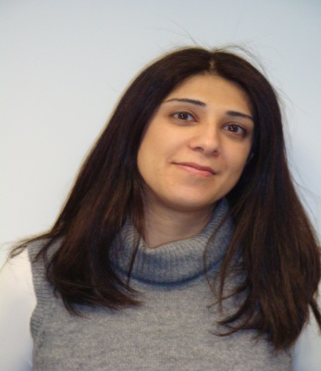 | Maria Georgiou

Maria is an experienced trainer, facilitator and coach, bringing energy and enthusiasm in all her interactions with people.

She is a Senior Manager at PwC working as a Human Resource Consultant and a Trainer. She is also responsible for Training and Development in PwC Cyprus. She has substantial experience in the design and delivery of management and leadership development programs, management workshops and executive coaching. With over 15 years of experience, she has worked in diverse industries including public sector, retail, financial services, hospitality and leisure and different countries in the Middle East and Europe. Her specialisation in these areas has been developed and enhanced by her recent certification as an Art of Innovation Leader.

Maria holds a BsC (Hons) in Management Sciences and an MsC in Industrial Relations and Personnel Management from the London School of Economics.

Maria gets energised by travelling and dancing and relaxes with reading. She has a passion for the Latin American culture, is dancing salsa and enjoys the works of Paulo Coelho and Mario Vargas Llosa.

